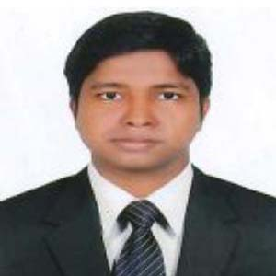

md. Omar faruk
C/O: Md. Jamal Uddin
Village: Boirati(College Para)
P.O: Karimpur
P.S: Kaligonj
Dist: Lalmonirhat
Cell: 01737-989607
E-mail: faruk.cu2011@gmail.com

CAREER OBJECTIVE

Focused and knowledgeable Chemist with a wide and deep knowledge base in industrial chemical processes. Adept at explaining complex chemical concepts to a variety of audiences. Especially skilled in safe and environmentally conscious experiment and process protocols.

ACADEMIC QUALIFICATION

Masters of Sciecne (M.Sc)
University : University of Chittagong.
Department : Chemistry
Result : CGPA 3.40 (Out of 4.00)
Passing Year : 2016

Bachelor of Science (B.Sc Hon’s)
University : University of Chittagong.
Department : Chemistry
Result : CGPA 2.69 (Out of 4.00)
Passing Year : 2015

Higher Scondary Certificate (H.S.C)
Institute : Karim Uddin Public College
Group : Science
Board : Dinajur
Result : GPA 4.30 (Out of 5.00)
Passing Year : 2010

Scondary School Certificate (S.S.C)
Institute : Kaligonj K.U.P Pilot High School
Group : Science
Board : Rajshahi
Result : GPA 4.94 (Out of 5.00)
Passing Year : 2008

Experience
- Organization Name: Tangil Residential College,
- Position : Lecturer
- Area: Ashulia, Savar, Dhaka.
- Duration: 30/06/2018 to till now.
- Job Responsibility: 1. Multimedia Class presentation.
2. Lab Maintenance
3. Lecture Sheet Maintenance
4. Class coordinator
INDUSTRIAL TOUR

- Usmania glass Sheet factory Ltd.
- Mohara water treatment plant.
- Transcom beverages Ltd. (Pepsi)
- Royal Cement Ltd.
- Banoful & Co. Ltd.
- S. Alam edible oil industries ltd.
- Bno Lubricant Ltd.
- Berger Paints Bangladesh ltd.
EXTRA- CURRICULAR ACTIVITIES

- Former vice president at Lalmonirhat student association of Chittagong University.
- Former president of Kaligonj student association of Chittagong.
- Member of CUDS.
- Played for Kaligonj sub district sheik football club.
- Played for Chemistry department Cricket team and become Champion up of inter science
Faculty team in 2014.
- Secretary of Lalmoinrhat University Students help organization.
PERSONAL INFORMATION

01. Name : Md. Omar Faruk
02. Father’s Name : Md. Jamal Uddin
03. Mother’s Name : Mst. Fazilatun Nesa
04. Date of Birth : 2nd Jun, 1992
05. Home District : Lalmonirhat
06. Permanent Address : Village: Boirati(College Para) P.O: Karimpur-5520
P.S: Kaligonj, Dist: Lalmonirhat
07. Religion : Islam
08. Blood Group : O+
09. Nationality : Bangladeshi
10. Marital Status : Single
Language Skills

Good command over speaking and writing proficient in reading, both English and Bengali.
Computer skills

Computer Office Application (Word, Excel, Power point, Access) & Internet Operation.
REFERENCES

- Professor Dr. Shamim Akhtar 02. Professor Dr. Syeda Khurshida Begum
Department of Chemistry Department of Chemistry
University of Chittagong, University of Chittagong,
Cell: 01712-090205 Cell: 01830-034350
PROCLAMATION

I hereby, declare myself that all the statement in these Curriculum Vita are correct and complete to the best of my knowledge and belief.

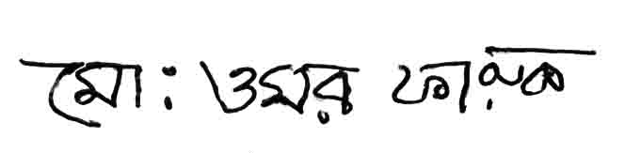

Md. Omar Faruk

